1. **Setup Hacking Lab (Describe the configuration with Steps) –**

-Download the vmware pro version from get into pc / official website

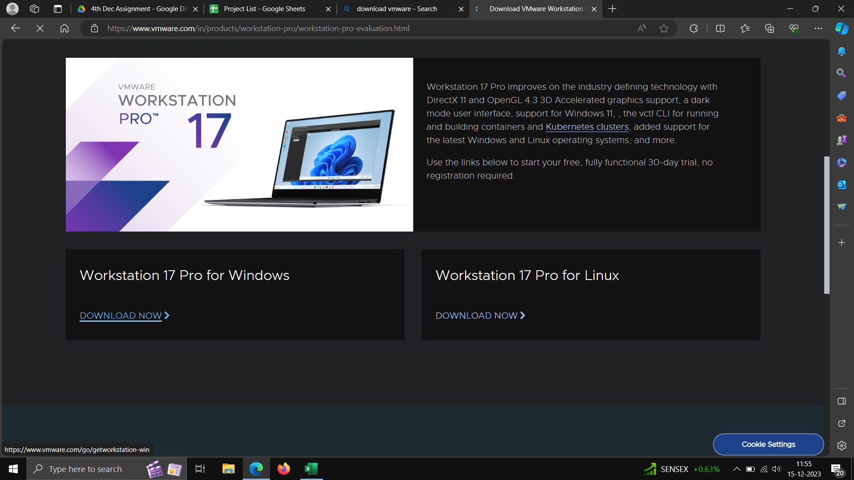

……………………………………………………………………………………………………………………………………

**Setting up vmware image disk**

**-Download kali linux vmdk file and metasploitable vulnerable machine from internet.**

**-Extract the file using 7zip.**

**Now create the new Vmware machine**

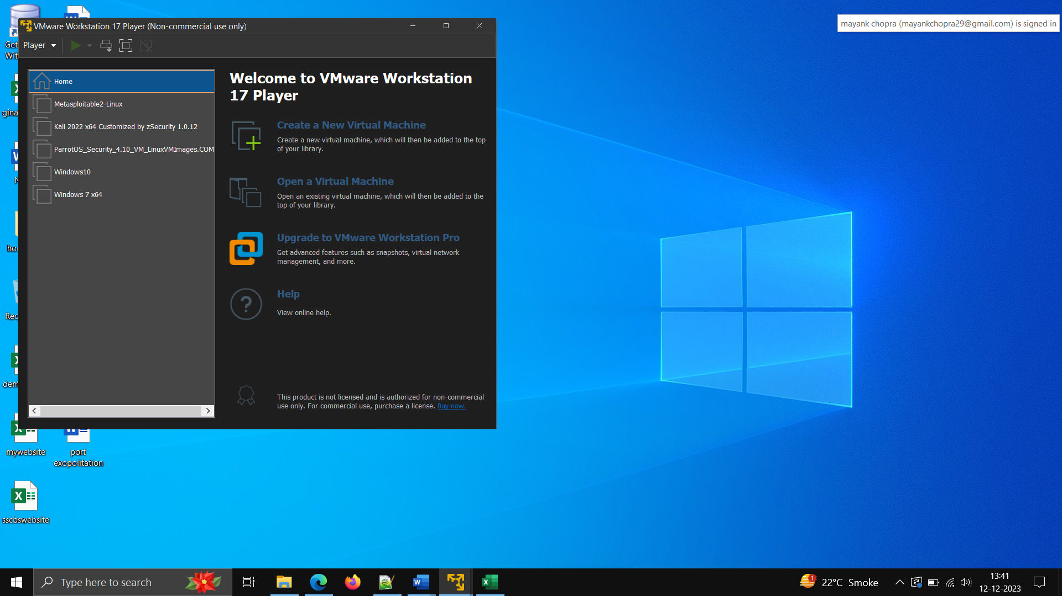

**Now run the machine ,its ready open the terminal and starting hacking**